**Cincinnati Reds Coaches Report:**

**Kerry Carpenter:**

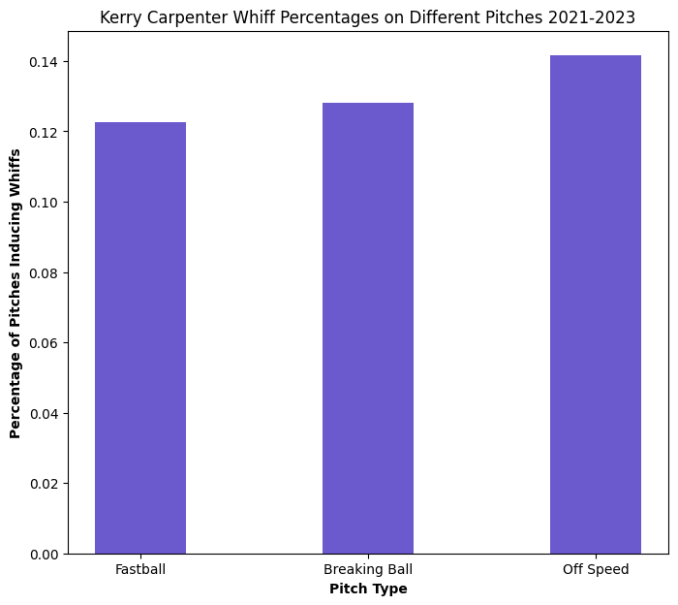 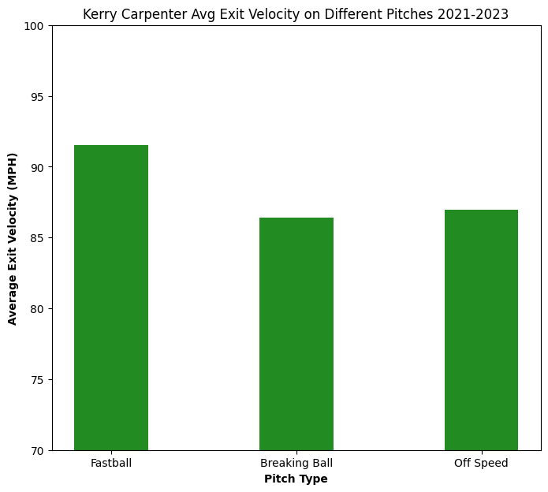

When looking at the predictions for 2024, the model gives the highest percentage of off speed pitches and the lowest percentage of fastballs. Although the proportions are close to equal for each pitch type, there is still slight differences which can have impacts in game scenarios. We can see from the 2 bar plots some interesting facts. First is that Kerry Carpenter crushes fastballs, with a pretty low whiff percentage. This aligns with what is known league wide, which is Kerry Carpenter is dangerous against fastballs. Kerry Carpenter has his highest whiff percentage on off speed pitches. Being able to mix pitches and setting up a off speed pitch as a strikeout pitch is a good strategy.

**Javier Baez:**

Javier Baez is predicted to get a heavy dose of breaking balls in 2024. Based on the whiff percentage, we can see why. Baez whiffs on a breaking ball more than 25% of the time. He also has a relatively high whiff percentage on off speed pitches. Based on the average exit velocities, he does the most damage on the fastball. To attack Javier Baez, it will be important to get into favorable counts and use the breaking ball and off-speed pitches to strike him out or get him to chase.